HTML

Contents

1. Introduction 2

How internet works? 2

Why an IP address? 2

How browser works? 5

2. HTML 7

Heading Element 7

Paragraph element 7

Void Elements 8

Unordered List 8

Ordered List 8

Anchor Elements 9

HTML Attributes 9

Image element 10

HTML Boilerplate Code 10

# Introduction

## How internet works?

* Imagine that we have developed a website, del.icio.us, which is up and running on our laptop. Now, if there's a random user on the internet who types "del.icio.us" into their browser and presses enter, they should be connecting to our laptop where our entire code is running.
* How do these users know that they need to connect to this particular laptop whenever they type "del.icio.us"?
* The first step when you're setting up a website is to buy the domain name.
* You visit one of these websites like **GoDaddy.com**, **Namecheap.com**, **domains.google.com**, or **BigRock.in**. There are plenty of them. You go to one of these websites and check whether the domain name del.icio.us is available.
* Let's say we go to **GoDaddy.com** and ask if the domain name del.icio.us is available or not.

##### Question 1:

* How does GoDaddy.com know whether the domain name del.icio.us is available or not?

##### Question 2:

* If the domain name del.icio.us is available, how can we buy it by paying some amount? How does this process work?

##### Answer:

* All of this can only happen if there is a central authority that maintains a list of all the domain names in the world.
* First, this authority tells whether a domain name is available or not.
* Second, if the domain name is available, **GoDaddy.com** will ask the central authority to assign this domain name to the user. **GoDaddy.com** will also make a payment to the central authority as they are an approved vendor or reseller.
* The central authority is **ICANN** (**Internet Corporation for Assigned Names and Numbers**), an American nonprofit organization that maintains the list of all domain names and their owners. ICANN charges a fee for every domain name to cover the cost of upkeep. The money they collect is used to manage the cost of running their infrastructure.
* All these websites like GoDaddy, Namecheap.com, domains.google.com, and BigRock.in are resellers.
* The second part of this process is: we buy del.icio.us. But just owning del.icio.us is not enough because we need a way to tell people that when they type del.icio.us, they should be directed to our machine. We have to tell the entire world that when you type del.icio.us, here is the IP address you should go to.

### Why an IP address?

* In the world of machines, the way to identify a device is through its IP address. Every machine on the internet has a unique IP address.
* Now, you might ask why we don't directly use IP addresses to access websites.
* It's because it's difficult to remember numbers, just like it's difficult to remember phone numbers. That's why we have a mapping system, where a domain name corresponds to an IP address.
* If we are the owner of del.icio.us, we need to be able to tell everyone that if somebody types del.icio.us, they should be directed to a specific IP address.
* **GoDaddy.com** provides you with an interface that says, "Hey, I have already saved your domain name because you've paid me. Do you also want me to save the IP address that people should go to?" You can then specify, for example, "Please use the IP address 10.20.30.40."
* This information will be stored with ICANN.

|  |  |  |
| --- | --- | --- |
| Domain | User | IP Address |
| del.icio.us | Nishith | 10.20.30.40 |

* Now, let's say someone goes to their browser and types "**del.icio.us**". One approach could be to have every browser in the world go to ICANN to check the corresponding IP address for del.icio.us.
* But if ICANN is the only place where the IP address is stored, do you think it's a good design for all browsers on the entire internet to go to ICANN for every single request on the web, whether it's for Google.com, del.icio.us, Facebook.com, or any other site?
* There is another entity that is very interested in ensuring that we find the IP address quickly, and that is typically our Internet Service Provider (ISP).
* ISPs have servers located all over the regions they serve. For example, if Airtel operates only in India, then throughout India, they will have many servers. These servers maintain a copy of the information stored in ICANN.

* These machines are called Domain Name Servers (DNS). What happens is whenever we type Google.com or Facebook.com, it goes to a DNS server and tries to fetch the IP address of the website. DNS servers are often maintained by ISPs.
* How does this server have a copy of ICANN's records? If it fetched a copy every single time, ICANN would be overloaded because millions of servers across the internet would keep asking ICANN for copies of all the records it has, and there are so many records.
* ICANN will ask when the last update was done and then send you only what has changed since that last update. For example, if the last update was on September 18 at 9 PM, you can request ICANN to provide only the entries that have changed after 9 PM. These changes would typically be very few. This process is called differential fetch or incremental fetch.
* Another scenario is if, for example, del.icio.us was just registered. Someone bought del.icio.us and assigned an IP address to it. It's possible that the update is reflected on one server, but another server, such as one maintained by Airtel (DNS), has not been updated yet. If you try to access del.icio.us, you might get a 'Site doesn't exist' error.
* One general expectation across the internet is that if you make any changes to a record in ICANN—whether it's creating a new record, editing, adding, or deleting existing records—it will take at least six hours for these changes to propagate across the internet.
* My next step is to go to godaddy.com, reserve a domain, and create a DNS record with the IP address. I wait for 24 hours so that all DNS servers across the world update with that IP address. The IP address I provide is my laptop's IP address.

##### Question: How does my laptop get an IP address?

* Typically, when any device connects to the internet, your internet service provider (ISP) allocates a unique IP address to it. This IP address could change every time you connect to the internet, and because of this, it is known as a dynamic IP address.
* Imagine I connected to the internet. As the owner of del.icio.us, I find that my laptop's IP address is 10.20.30.40, so I go to godaddy.com and set the IP address to 10.20.30.40. Now, when someone types del.icio.us, they should be redirected to 10.20.30.40.
* However, there is a problem. What if I get disconnected and then reconnect? With a dynamic IP address, there is no guarantee that I'll get the same IP address again. This time, let's say my IP address changes to 10.20.30.50.
  + What will happen when people type del.icio.us in their browsers? They will get a 404 error.
* If my IP address changes, I would then go to godaddy.com and update it to 10.20.30.50. The problem is that even if I update the IP address, it can take several hours for the change to propagate to all DNS servers. So, people may have trouble accessing del.icio.us for the next few hours.
* This is where the concept of a static IP address comes in. A static IP address means that I pay an extra fee to my internet service provider. For example, if my ISP is Airtel, I pay extra to get a leased connection with a dedicated static IP address. In this case, every time I connect to the internet, I will have the same IP address (e.g., 10.20.30.40), which will not be assigned to anyone else. In that case, you would need to pay the new ISP for a new IP address.
* As the owner of del.icio.us, I have now purchased the domain on godaddy.com. I have also set up the DNS entry on godaddy.com, ICANN, and all relevant DNS services. I ensured that my IP address does not change by purchasing a static IP address.

##### Question: Now, what happens if someone types del.icio.us in their browser?

* The browser checks its cache to see if it has previously visited del.icio.us. If it already has the IP mapping, it uses that.
* If the IP mapping is not in the cache, the browser queries the DNS server to check if there is an entry for del.icio.us. The DNS server then responds with the IP address 10.20.30.40.
* 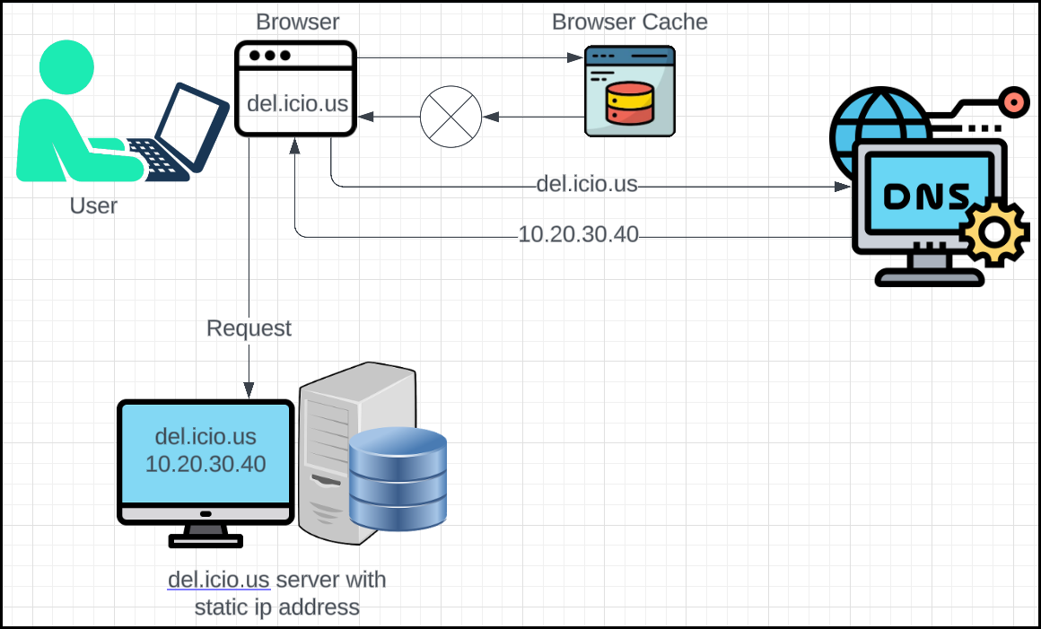Now, my laptop receives this request, and it runs my code that displays a webpage, such as a login page.

## How browser works?

* When a user makes a request to a service like del.icio.us, the server typically responds with a single file containing a combination of
  + HTML
    - While HTML can contain text, images, buttons, and other elements, it's primarily a **structure language**. It defines the *layout* and *organization* of content on a webpage.
    - HTML elements act as containers for other content, such as text, images, or links
  + CSS
    - CSS is indeed a **styling language**. It's used to define the *appearance* of HTML elements.
    - It specifies things like colors, fonts, sizes, spacing, and layout properties.
    - CSS rules are applied to HTML elements to change their visual presentation.
  + JavaScript code
    - It's used to add *interactivity* and *functionality* to web pages.
    - It can handle user interactions.
    - JavaScript code is often embedded within HTML files or linked to separately.
* The browser starts loading the HTML file first, as it's the foundation for the page structure. However, the user might not see any content immediately, especially if the HTML file is large or if there are external resources to load.
* CSS loading: Once the browser has a basic understanding of the HTML structure, it starts loading the CSS file. As CSS rules are applied, the user might see elements changing shape, color, or layout in real time.
* JavaScript loading: JavaScript files can be loaded at different points in the page loading process.

# HTML

* HTML stands for Hypertext Markup Language.
* **Hypertext** is a text that contains **links to other text**. These links, often called "**hyperlinks**", can be clicked on to access the linked information immediately.
  + Think of it like a book where words or phrases are underlined or highlighted. When you click on one of these underlined words, it takes you directly to another page in the book or even to a different book entirely.
* **Markup languages** are used to define the structure and content of documents. They do this by using tags, which are special words or symbols that indicate how the text should be formatted or displayed.
  + Think of it like using bold or italic font in a word processor. These formatting options are specified using markup.
* HTML (Hypertext Markup Language) is the most common markup language used for creating web pages. It uses tags like <p> for paragraphs, <h1> for headings, and <a> for links.

## Heading Element

* The <h1> tag is used for heading element.
* Example:

* In HTML, <h1> is the tag used to define the most important heading on a web page. It's typically the largest and most prominent heading.
* There are other heading tags available as well:
  + <h2>: Subheading
  + <h3>: Sub-subheading
  + <h4>: Fourth-level heading
  + <h5>: Fifth-level heading
  + <h6>: Sixth-level heading

## Paragraph element

* The <p> element in HTML is used to define a paragraph.
* It's a basic building block for structuring text content on a web page. When you place text within <p> tags, the browser will automatically insert a line break after the text and start a new paragraph.

## Void Elements

* Void elements in HTML are elements that don't have any content. They are self-closing and don't require an end tag.
* <hr/> and <br/> are two common examples of void elements:
  + <hr/>: This element represents a horizontal rule, which is a line that separates content on a page.
  + A close-up of a text

    Description automatically generated<br/>: This element represents a line break. It forces the content that follows to start on a new line. (Example: Poem)

## Unordered List

* Purpose: To create a list of items that are not in a specific order.
* Tag: <ul>
* List items: <li> tags are used within <ul> to define individual list items.

## Ordered List

* Purpose: To create a list of items that are in a specific order, typically numbered or lettered.
* Tag: <ol>
* List items: <li> tags are used within <ol> to define individual list items.

## Anchor Elements

* Purpose: To create links to other web pages, files, or sections within the same page.
* Tag: <a>
* Attributes:
  + href: Specifies the URL of the linked resource.
  + target: Specifies where to open the linked resource (e.g., "_blank" for a new tab).



## HTML Attributes

* HTML attributes are used to provide additional information or properties to HTML elements. They are placed within the opening tag of an element and consist of a **name** and a **value**, separated by an equal’s sign.
  + General Attributes
    - id: Unique identifier for an element.
    - class: Specifies one or more class names for an element.
    - title: Provides a tooltip for the element.
    - style: Specifies an inline style for an element.
    - lang: Specifies the language of the element's content.
  + Specific Attributes
    - src: Specifies the URL of a resource (e.g., image, audio, video).
    - alt: Provides an alternative text description for an image.
    - href: Specifies the URL of a linked resource.
    - target: Specifies where to open a linked resource (e.g., "_blank" for a new tab).
    - value: Specifies the value of an input element.
    - A screenshot of a computer

      Description automatically generatedtype: Specifies the type of an input element (e.g., "text", "checkbox", "submit").

## Image element

* The <img> element in HTML is used to display images on a web page. It requires the src attribute to specify the URL of the image file. It is a **void element**.
* Attributes:
  + src: Specifies the URL of the image file.
  + alt: Provides an alternative text description for the image, which is important for accessibility and search engine optimization.
  + width: Specifies the width of the image in pixels.
  + height: Specifies the height of the image in pixels.
  + title: Provides a tooltip for the image.
  + A white rectangular object with black text

    Description automatically generatedstyle: Allows you to apply inline styles to the image

## HTML Boilerplate Code

* A boilerplate code is a basic template that can be used as a starting point for creating a new HTML document.
* A diagram of a computer program

  Description automatically generated with medium confidenceIt provides a structured framework with essential elements and attributes, saving you time and ensuring consistency.